Teen Life Interview with Ruby Zatz (January 2013)
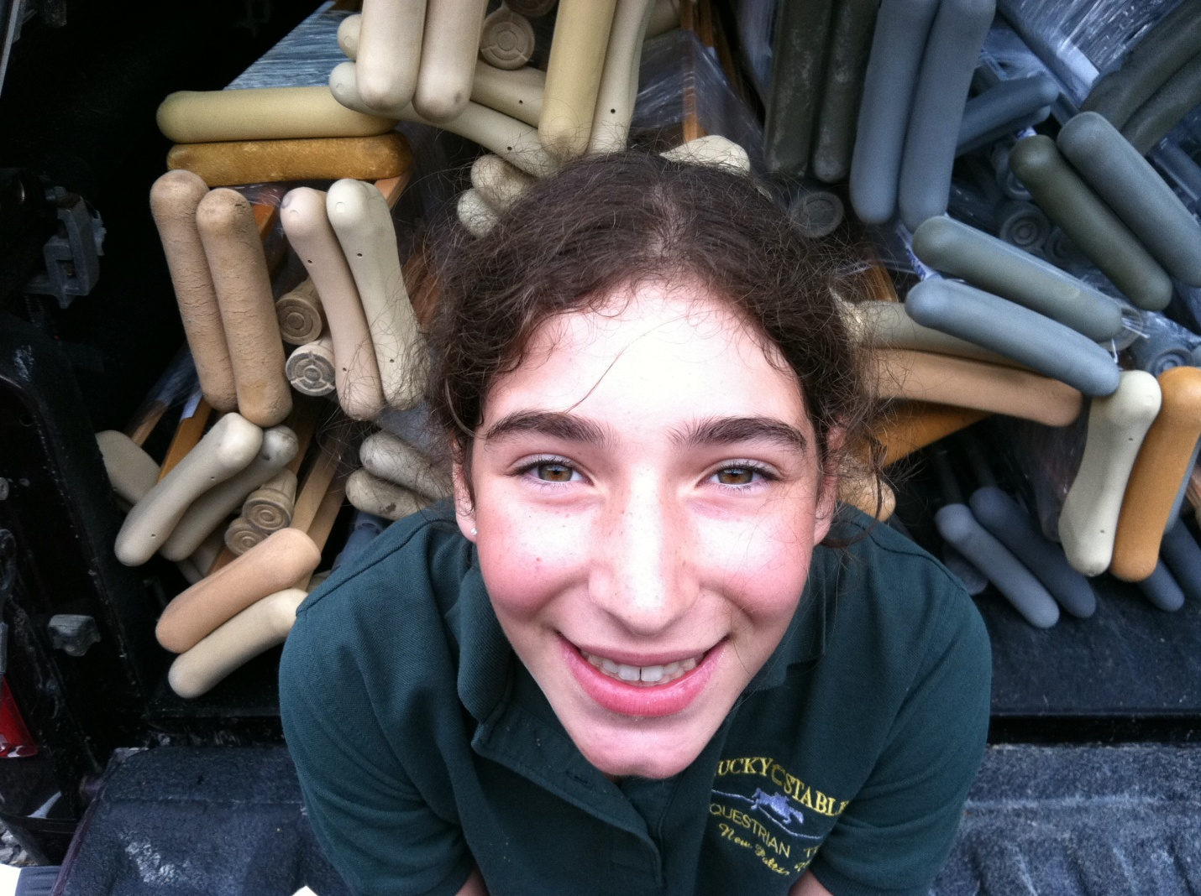
- What was the name of the Service Program did you participate in?
Crutches For Kids (C4K)
- Tell me a little bit about the program and its mission?
Crutches For Kids is a non-profit organization that collects crutches for those in need of mobile assistance. In countries that suffer natural disasters and wars, innocent victims, perhaps even people who have been rescued, are hospitalized for amputations and other emergencies. They may recover and become well enough to leave the hospital, but how? Crutches are a huge part of recovery. C4K brings mobility to the lives of those who need it. Mobility is an essential part of human life, and without it, people cannot partake in work, school, community activities and gatherings. They can’t live their lives to the fullest. Crutches 4 Kids collects crutches and then - working with other organizations – delivers them to the parts of the world that need them most. I collected over 200 crutches last year that went to help in Sierra Leone. This year’s collection went to Haiti.
- Why did you start volunteering?
I started volunteering for C4K a few summers ago. Community service has always been part of my life, from fostering homeless dogs to volunteering at the local blood drive. Working in my community is very important to me: I serve at our spaghetti dinners that offer low cost meals to those that attend and I set up our small town fair. My dad came up with the idea of contacting Crutches for Kids and setting up a crutch drive. I loved the idea and made an elaborate power point to describe and promote C4K and its mission. As I did some more research, I found out a lot about their goals and how I could help make those goals a reality. I have organized two crutch drives over the past two summers and hope to continue putting drives together for years to come!
- What tasks did you carry out as part of your community service work? Projects worked on?
I had to make posters, flyers, and boxes for the crutch drive and also had to go to many of the local businesses to ask if we could make their store a crutch drop off point. We placed the boxes around two towns and promoted the drive wherever we could. The drives last about one month. I also got an article placed in the local newspaper on the crutch drive and where the drop-off points were. My dad and I checked the boxes every few days to pick up the crutches and take them home. After the drive was over, I wrote a “letter to the editor” of the local papers and thanked all the businesses that participated in the crutch drive. On top of this, I sent a letter to the storeowners so they knew how much it helped that they volunteered as drop off points. After we counted the crutches (we had over 200!!), we put C4K stickers on each of them and wrapped them in shrink-wrap in groups of 10 so they were easier to ship. They were then dropped off at the company that was shipping them and that’s where my work ended. During the entire program, we stayed in touch with Melody Woodford from C4K who was our contact and who was very supportive and appreciative.
- What was the most memorable part of your experience?
There were lots of memorable parts of this experience, one being counting the crutches and thinking: “How did I do this?” But probably the most memorable experience was getting the email saying that my 200 crutches were sent to Sierra Leone in Africa. Sierra Leone is home to 20% of the world’s amputees and an extreme amount of polio victims. And from that information, I knew I had begun to make a difference in the world.
- What has been the most rewarding part of the experience (could be same as 5)?
The most rewarding part of the crutch drive was definetly what I said before about the crutches being donated to Sierra Leone. Because of this, I could tell that the crutches I had worked to collect were not going to waste, they were going to help 100%, and that is all I needed to hear. It made me feel like I was a part of this world and that I was doing my part to help the people who inhabit this world.
- What has been the most challenging aspect of this volunteer work?
The most challenging aspect of putting together the crutch drive was probably budgeting my time. I had a deadline to get the posters and boxes set up before the drive started. And when it did begin, I constantly wanted to check the boxes to see if we had gotten any new crutches. But I couldn’t have done the drive without my dad’s help keeping me on track. He said that I was in complete control of this project and that his job was to make sure I stayed on task. I don’t know what I would’ve done without him.
- What did you learn by participating in this program?
From participating in the C4K crutch drives, I learned the importance of helping others, even if you don’t really know them. When I volunteer locally, I usually am connected to them somehow and the pats on the back come from people I know. With C4K, I was able to work on an important project helping people I didn’t know personally so the rewards were all personal and I got to congratulate myself. We are all living together on Earth so why not help each other out?
- What skills have you gained that you think could help you in your career?
I have gained so many skills from C4K and the crutch drives that I don’t even know the kind of person I would be without them! First off, it has helped me become organized. This project requires lots of focus and organization, two skills that were alien to me. But now, I understand the importance of being organized in most of what a person does in life. From talking with the all of the storeowners, I have improved my communication skills. I never realized how hard it is to present to people you’ve never met before! In the future, most of the job fields I would want to work in require making connections on a daily basis!
- Has volunteering changed your view of the world?
Definitely! Volunteering has given me a sense of the world. Community service has helped me realize that we are all here to help each other. I now see that I can help people just as much as people that receive Nobel Prizes.
- How did it shape your future goals in school and life moving forward.
Volunteering for C4K has made me set my expectations higher because I know what I can accomplish now. The skills that I have gained from this experience will help me in school, life and in a future career. One day I want to start my own non-profit organization and try to help the world in my own way. Without Crutches for Kids I would not be the person I am today. I am also thinking about starting a crutch drive in my school since we are very community service oriented and I know the kids will love it!
- Any advice for other teen volunteers looking for a rewarding and fulfilling opportunity?
If any other teens are looking for volunteer work that will help others and is very rewarding, I strongly recommend Crutches for Kids. It’s not the typical in school community service project. Crutch drives are easy to get together and help people globally, not just in your neighborhood. C4K is a great way to start a life of volunteering and helping those who need it!! They have a website at www.crutches4kids.org which tells you all about the program.

